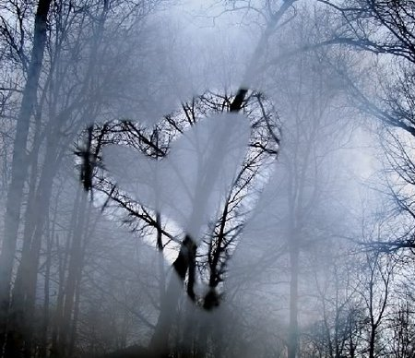  February | 2015

Sunday | Monday | Tuesday | Wednesday | Thursday | Friday | Saturday
1 | 2 | 3 | 4 | 5 | 6 | 7
1st WS Gold Coast Singers Rehearsal  Room 327 ASC  1:30PM-4:00PM | Groundhog’s Day | Choir Rehearsal  Room 327 ASC  7:00PM | CW: 5:00PM  WS: 6:30PM  ‘Master Harold’ & The Boys  Center Stage Theater 7:30PM | Jazz Rehearsal  Room 331 ASC  5:30PM
8 | 9 | 10 | 11 | 12 | 13 | 14
WS Gold Coast Singers Rehearsal  Room 327 ASC  1:30PM-4:00PM |  | Choir Rehearsal  Room 327 ASC  7:00PM | Rehearsal  Room 331 ASC  CW: 5:00PM  WS: 6:30PM | Jazz Rehearsal  Room 331 ASC  5:30PM |  | Valentine’s Day
15 | 16 | 17 | 18 | 19 | 20 | 21
WS Gold Coast Singers Rehearsal  Room 327 ASC  1:30PM-4:00PM |  | Choir Rehearsal  Room 327 ASC  7:00PM | Rehearsal  Room 331 ASC  CW: 5:00PM  WS: 6:30PM | Jazz Rehearsal  Room 331 ASC  5:30PM
22 | 23 | 24 | 25 | 26 | 27 | 28
WS Gold Coast Singers Rehearsal  Room 327 ASC  1:30PM-4:00PM |  | Choir Rehearsal  Room 327 ASC  7:00PM | Rehearsal  Room 331 ASC  CW: 5:00PM  WS: 6:30PM | Jazz Rehearsal  Room 331 ASC  5:30PM | The Cashore Marionettes  Ludington Area Center for the Arts  7:30PM

